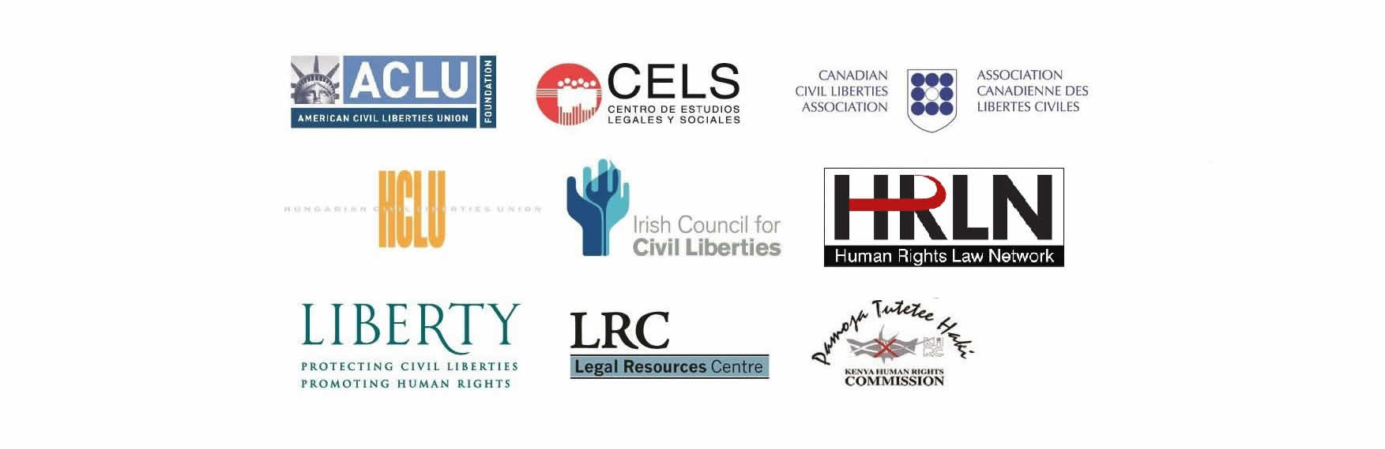

MEMBERS OF INCLO CALL FOR HOSSAM BAGHAT'S IMMEDIATE RELEASE

On the 5th November, Hossam Bahgat, journalist and founder of human rights group Egyptian Initiative for Personal Rights, received a summons from Military Intelligence. He attended their headquarters on Sunday morning where he was interrogated, without legal counsel, for many hours. Yesterday, Military Prosecution ordered his detention for four days. It is not known where he is being detained.

And the heinous crime for which he is being punished? Hossam has published on Mada Masr a series of investigative reports primarily in relation to the October 13th investigative report on the military trial of 26 officers for allegedly plotting "regime change". The charges are said to be “deliberately spreading false information with the purpose of harming public order or public interest” and “publishing, with malicious intent, false news that is likely to disturb public order.” It should be noted however that his investigative report relied extensively on official, military court documentation. These charges represent yet another attempt by the Egyptian authorities to stifle free expression and crush independent media – the cornerstone of any free society.

Hossam Bahgat must be freed immediately, without charge and we call on our respective Governments to use their influence with the Egyptian Authorities to demand his release.

The following organizations are members of the International Network for Civil Liberties Organizations (INCLO):

American Civil Liberties Union (ACLU)
Canadian Civil Liberties Association (CCLA)
Centro de Estudios Legales y Sociales (CELS, Argentina)
Human Rights Law Network (HRLN, India)
Hungarian Civil Liberties Union (HCLU)
Irish Council for Civil Liberties (ICCL)
Kenya Human Rights Commission (KHRC)
Legal Resources Centre (LRC, South Africa)
Liberty (UK)

